CPE23 – Computer Architecture & Organization
Midterms
The Arithmetic and Logic Unit
Introduction to Processor ALU | - Overview of the Processor  - Central role of the processor in executing instructions  - Relationship between the Control Unit (CU) & Arithmetic Logic Unit (ALU)  - Introduction to the Arithmetic and Logic Unit (ALU)  - Definition & Core functions of ALU  - Operations supported: arithmetic, logic, shifting, & comparison  Importance of ALU in system performance
Focus on Computer Arithmetic | - Definition and Scope  - Computer arithmetic as the most complex aspect of the ALU  - Distinction between logic operations and arithmetic operations  - Importance of Computer Arithmetic  - Role in everyday processor task (e.g. calculations, decision-making, data processing)  - Influence on hardware design, speed, and accuracy
Integer Representation
- Sign-Magnitude Representation
- Two Complement Representation
- Range Extension
- Fixed Point Representation
Integer Arithmetic
- Negation
- Addition and Subtraction
- Multiplication
- Division

The Arithmetic and Logic Unit
- Arithmetic Logic Unit (ALU) | - Definition  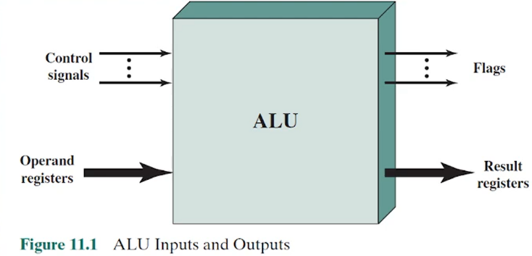  The Arithmetic and Logic Unit (ALU) is the core computational engine of the CPU. It performs arithmetic operations such as addition, subtraction, multiplication, and division, as well as logical operations like AND, OR, XOR, NOT, and comparisons. Every computer program reduces to a sequence of ALU operations.  - Relationship with Other Components  - Registers: Supply operands to the ALU and store results.  - Control Unit: Provides control signals to specify which operation to perform.  - Flags/Status Registers: Store outcomes such as zero, carry, overflow, and sign.
- Integer Representation | - Why Representation Matters  Computers represent values in binary (0s & 1s). Since binary lacks explicit signs or decimal symbols, specific encoding methods must be used for signed numbers.  Binary Number Representation  - Fundamental Symbols in Number Representation  - Digits: 0 and 1 (binary digits or bits)  - Minus sign (-) for negative numbers  - Period or radix point (.) for fractional components  - Example of a Binary Fraction  - Example: -1101.0101₂ = -13.3125₁₀  - Demonstrates both integer and fractional components  Computer Constraints in Representation  - Absence of Special Symbols in Storage  - Computers cannot store the minus sign as a separate symbol  - Computers cannot directly store the radix (decimal/binary) point  - Limitation to Binary Digits  - Only 0 & 1 are available for internal representation  - Additional methods are needed to represent negatives and fractions  - Unsigned Integers  Unsigned integers represent only non-negative numbers.  Range: 0 to 2^{n-1}  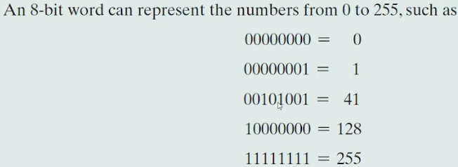  Example (8-bit): 00000000 = 0, 11111111 = 255.  - Sign-Magnitude Representation  - Introduction to Signed Number Representation Need for Representing Positive and Negative Integers  Binary numbers originally suited for non-negative integers only.  Conventions required to include negative values  General Principle: Use of a Sign Bit  Most significant bit (MSB) reserved as the signed bit  0 -> positive number  1 -> negative number  - Sign-Magnitude Representation-Definition and Structure  Basic Concept  Simplest representation that uses a sign bit  Structure in an n-bit word:  Leftmost bit = sign  Remaining (n-1) bits = magnitude of the integer  Example Representation  +18 = 00010010  -18 = 10010010  Both share the same magnitude bits, differing only in the sign bit  - Drawbacks of Sign-Magnitude Representation  - Complexity in Arithmetic Operations  - Addition and subtraction require considering both:  - The sign of the operands  - The relative magnitudes  - More complicated than two’s complement arithmetic  - Dual Representation of Zero  - Positive zero: 00000000  - Negative zero: 10000000  - Causes inefficiency in hardware:  - More difficult zero testing (frequently used operation)  - Ambiguity in representation  - Practical Limitation  - Rarely used in modern computer systems for integers  - Replaced by two’s complement for efficiency and simplicity.

Chapter 4: The Memory Hierarchy: Locality & Performance
4.1 Principle of Locality | One of the most important concepts related to computer systems is principle of locality, also referred to as the locality of reference. The principle reflects the observation that during the course of execution of a program, memory references by the processor, for both instructions and data, tend to cluster.
2 Forms of Locality
Temporal Locality | Refers to the tendency of a program to reference in the near future those units of memory referenced in the recent past.  For example, when an iteration loop is executed, the processor executes the same set of instructions repeatedly. Constants, temporary variables, and working stacks are also constructs that lead to this principle.  When Bob is working on a file and temporarily is finished, it may be likely that he will need to read or write one of the documents in that file in the near future, so he keeps it in his desk organizer. This is an example of exploiting temporal locality.
Spatial Locality | Refers to the tendency of a program to reference units of memory whose addresses are near one another. That is, if a unit of memory x is referenced at time t, it is likely that units in the range x - k through x + k will be referenced in the near future, for a relatively small value of k. This reflects the tendency of a processor to access instructions sequentially. Spatial location also reflects the tendency of a program to access data locations sequentially, such as when processing a table of data.  Bob also observes that when he retrieves a folder from the filing cabinets, it is likely that in the near future he will need access to some of the nearby folders as well, so he retrieves the folder he needs plus a few folders on either side at the same time. This is an example of exploiting spatial locality.
Static instruction | An instruction that exists in the code to be executed
Dynamic instruction | Instructions that appear in the execution trace of a program
4.2 Characteristics of Memory Systems

Location | refers to whether memory is internal or external to the computer.
Internal memory | - Is often equated with main memory, but there are other forms of internal memory.  - An obvious characteristic of memory is its capacity. For internal memory, this is typically expressed in terms of bytes (1 byte = 8 bits) or words. Common word lengths are 8, 16, and 32 bits.  - Related concepts for internal memory:  - Word: The “natural” unit of organization of memory. The size of a word is typically equal to the number of bits used to represent an integer and to the instruction length.  - Addressable units: In some systems, the addressable unit is the word. However, many systems allow addressing at the byte level. In any case, the relationship between the length in bits A of an address and the number N of addressable units is 2A = N  - Unit of transfer: For main memory, this is the number of bits read out of or written into memory at a time. The unit of transfer need not equal a word or an addressable unit. For external memory, data are often transferred in much larger units than a word, and these are referred to as blocks  Method of Accessing  - Sequential access: Memory is organized into units of data, called records. Access must be made in a specific linear sequence. Stored addressing information is used to separate records and assist in the retrieval process.  - Direct access: As with sequential access, direct access involves a shared read–write mechanism. However, individual blocks or records have a unique address based on physical location. Access is accomplished by direct access to reach a general vicinity plus sequential searching, counting, or waiting to reach the final location.  - Random access: Each addressable location in memory has a unique, physically wired-in addressing mechanism. The time to access a given location is independent of the sequence of prior accesses and is constant. Thus, any location can be selected at random and directly addressed and accessed. Main memory and some cache systems are random access.  - Associative: This is a random access type of memory that enables one to make a comparison of desired bit locations within a word for a specified match, and to do this for all words simultaneously.  - Performance Parameters are used:  - Access time (latency): For random-access memory, this is the time it takes to perform a read or write operation, that is, the time from the instant that an address is presented to the memory to the instant that data have been stored or made available for use. For non-random-access memory, access time is the time it takes to position the read–write mechanism at the desired location.  - Memory cycle time: This concept is primarily applied to random-access memory and consists of the access time plus any additional time required before a second access can commence. This additional time may be required for transients to die out on signal lines or to regenerate data if they are read destructively. Note that memory cycle time is concerned with the system bus, not the processor.  - Transfer rate: This is the rate at which data can be transferred into or out of a memory unit. For random-access memory, it is equal to 1/(cycle time).
External Memory | - Consists of peripheral storage devices, such as disk and tape, that are accessible to the processor via I/O controllers.  - External memory capacity is typically expressed in terms of bytes.
Unit transfer | For internal memory, the unit of transfer is equal to the number of electrical lines into and out of the memory module. This may be equal to the word length, but is often larger, such as 64, 128, or 256 bits.
Physical types of Memory | - Semiconductor memory (either volatile or non-volatile)  - Magnetic surface memory (non-volatile)  - …used for disk tape and tape  - Optical and magneto-optical
Physical characteristics of memory | - Volatile memory: information decays naturally or is lost when electrical power is switched off.  - Nonvolatile memory: information once recorded remains without deterioration until deliberately changed; no electrical power is needed to retain information.
Organization | Refers to the physical arrangement of bits to form words.
4.3 The Memory Hierarchy

